From Pantser To Plotter:
The Mac-Daddy of All Pantser Vs. Plotter Articles
(Originally compiled for Left Behind And Loving It 2009)
By: Kait Nolan

From Pantser To Plotter: Why The Pantser Fears Plotting
by Kait Nolan
When Lynn did her call for Left Behind and Loving It contributors this year, I decided right off that I wanted to do a series chronicling my shift from pantser to plotter. It’s a conversion that many have made and even more fear. There’s this idea that one is born a pantser or a plotter and that never the twain shall meet.
Well, I’m living proof that that isn’t the case.
Before I go on, I feel compelled to offer a definition of this term for any who are unfamiliar with it. A “pantser” is someone who writes by the seat of their pants without a plan, without an outline, merely allowing the story and characters to go where they will. A “plotter”, by contrast, usually has some measure of plan, outline, or story map to follow before they begin writing.
All my writing life (from the age of 12 on), I have been a pantser. I tend to get bitten by the bug for a new story and I take the bit in my teeth and run with it as fast and far as I can. Inevitably this tends to run out somewhere in the vicinity of the Dreaded Valley of the Shadow of the Middle (DVSM). That’s usually the point at which I begin to wish I had a map or outline of some kind to follow so that I know what comes next. But I, like many of my fellow pantser compatriots, feared plotting.
There are many reasons for such fear. I’ll spare you the deep, psychological analysis and narrow it down to some of the most popular fears I’ve heard among fellow pantsers. Among them are:
- It will kill creativity: Many pantsers are convinced that if they do try to hammer out an entire plot before writing that it will simply kill their creativity–that their plot will simply drown like an overwatered houseplant.
- I work organically: Many pantsers feel that their plot grows out of the story itself as it is written, sprouting forth new growth each day like kudzu. They feel that plotting goes entirely against that organic approach and that fixing the story in a hard and fast outline will, again, kill their creativity.
- I learn my characters as I go: This was a huge one for me. Sometimes I will know one or two of my characters before I ever put a word on the page, but more often, I simply learn them as I go. How can I possibly plan an entire book around characters that I don’t know yet? If I don’t know them, I don’t know what they will do or how they will react to certain situations. Ergo, I cannot plot.
- Knowing what happens–where’s the fun in that? Also a huge one for me. I really love the surprise in writing. I adore when my characters pop up and do something unexpected. Knowing exactly what happens and having a detailed outline absolutely ruins that surprise. It’s like being that kid who peeks at presents before Christmas morning.
- It’s boring: The entire process of plotting is boring. There’s none of the fun of snappy dialogue or the drama of conflict. It’s like writing out the main points of a research paper–which is one of the most horrifyingly boring thinks you can do. Which brings us to…
- Feels like school: That research paper? Yeah it’s like doing homework. It sucks and it’s not fun. And finally…
- Dude, it’s HARD! Plotting is not for the faint of heart. Anybody who thinks that plotting–real plotting wherein you figure out an entire plot, built on a solid foundation of Goal, Motivation, and Conflict for the characters–is not easy. Like dieting, every time I tried I wound up falling off the wagon. Pantsing is like cookie dough–it is my diet Kryptonite–or rather my writing Kryptonite.
For some people, I really think that they feel that plotting, which is, by its very nature, a very organized sort of activity, is the absolute antithesis of the artistic personality. There’s this connotation that we’re supposed to be these organic, not quite connected to reality kind of people. Many pantsers see plotting as work. And, well, it is. I have also heard some pantsers talk with a sort of disdain for plotters, as if taking the time to plot and figure things out on the front end somehow diminishes the accomplishment of writing a book. I’ve heard born plotters (they do exist) look to pantsers (or rather their end results) with a sort of awe that they were able to take that leap of faith and just write. There’s a certain expectation that the pantser is somehow better because they don’t have to plot and organize. As if the initial imaginative spew IS the thing we read on the published page.
To that, I say, have you ever read a pantser’s true first draft? I daresay most of them bear very little resemblance to their final product. When picking your way through the pantser/plotter dynamic, never ever forget that there is much editing and revision involved.
Whether such prejudices are on the pantser side or the plotter side, they are simply not true. And that’s something I had to learn the hard way over the last three years. Despite my assorted fears, something in me kept pushing me to try to plot. I had a number of problems with pantsing that I’ll talk about tomorrow.

From Pantser To Plotter: My Problems With Pantsing
by Kait Nolan
At first I was afraid, I was petrified…
And then I started taking a realistic look at the problems that pantsing was causing me. (Warning, I am about to shamelessly mix metaphors)
Tangents
When I write by the seat of my pants, I have a really bad habit of going off on tangents. Like psychotic rabbits on speed, bouncing off the wall of plot tangents. Some “what if…?” idea will occur to me and I’ll run with it, displaying that same enthusiasm that usually accompanies fresh ideas. Except that instead of Sexy Next Book, it’s Sexy Next Plot Idea. Never mind that SNPI may have no bearing on the heart of my plot. I’ll go back and tie it in during revisions. Never mind that SNPI is the height of self indulgence because I really want my heroine to take this new turn in life and quit her job and open a bookstore, even though there’s a killer on the loose. You see my point? Without having at least a loose outline to hang the plot on, I’m absolutely guilty of going off on tangents. Tangents that I ultimately have to cut during revisions. Tangents that I wasted weeks or months of writing time on, the holes of which (after cutting) must still be filled. This is a monumental waste of writing time.
The Dreaded Valley of the Shadow of the Middle
Ah yes, the DVSM. I despise the DVSM. This is the point in the writing journey with every single book where I start to question my fortitude because once I run out of that initial creative steam, I am left standing on the precipice of the DVSM with no idea what happens next. Which leads to tangents (see above). I limp through, throw a bunch of scenes in, which theoretically get me from the first third to the last with nothing more than creative ingenuity, spit, and duct tape. Such construction does not a good novel make. Middles are the weak spot for SO MANY novels and account for a huge percentage of the volume of New York’s slush piles. And I honestly believe that weak middles are very often a symptom of pantsing. Not always, but very very often. They are the fatty, flabby, un-toned abdomen of your novel. And over here in the other corner are the plotters, with six pack abs on their novels. C’mon, don’t you want those six pack abs?
The Rambling Road To Finished Is The Road Trip From Hell
Every book is a journey. We’ve all heard that metaphor before. And it is. As a pantser, you’re starting out on a road trip with a vague destination in mind, maybe you know you’re travelling companions. Maybe you just know where you want to end up. But you set out without a map. And inevitably you make a wrong turn. A lot of them. And what should have been a grand adventure turns into the Roadtrip from Hell (or perhaps to Hell, depending). You hooked a right by that gas station 50 miles back and now you’re in Deliverance country. Or maybe the ghetto. Or any other number of places you do not want to end up on a road trip. And even if you make it to the end of this Road Trip From Hell and get a finished draft, there is still the issue of–
Massive Revisions Necessary
Yep, revisions. You pantsed your way all the way to the end of a manuscript. Now you have to turn it into something salable. You have to wade back through the mess and see what’s salvageable. Because that’s what revisions are, very often, when people pants (not always–some pantsers wind up with a very solid book at the end, but I’d say they are the exception rather than the rule). Revisions become a salvage mission to cut out the usable material and figure out what you can do to renovate the poor foundation you started with, shore it up, and create something more solid. It’s a balancing act. And sure, it can be done. I’ve finished 4 books this way. A couple of them even turned out decently and not entirely full of suck. But the graveyard of abandoned projects littering my hard drive is good proof that there are many dozens more that I didn’t.
The long and the short of it is that pantsing (for most of us) is hideously inefficient. You waste time and effort on tangents and wrong turns because you didn’t take the time to plan your trip out ahead of time. Some people are okay with that. If you’re that person, then pants to your heart’s desire. But if you’re like me and writing is not your primary occupation and you want it to be, then it would behoove you to think about learning to plot. Now lest you be frightened away, let me say this. Pantsing and Plotting are not either/or propositions. As one commenter mentioned yesterday, it really is a continuum with pantsing on one end and plotting on the other. If you are a hard core pantser, then maybe you just want to bump a couple of notches toward the plotting end. That’s totally okay. As with all writing, there is no right or wrong way to do things. Everybody has their own methods. Over the course of the rest of the week, I’ll be sharing with you some of mine, and maybe you’ll luck out and find something that you can make work for you.

From Pantser To Plotter: My Conversion, Part 1
by Kait Nolan
My going from Pantser to Plotter has been a multi-step process.
There is a misconception, I think, among pantsers that to be a plotter you must become some kind of Plot Nazi with notecards and color coded charts and every single aspect of every scene figured out before you ever put pen to paper or butt in chair to write the first word of actual prose.
This is a great big gigantic myth.
Yes, those people do exist (and I find them really scary), but that doesn’t mean you have to be like them. There are as many methods of plotting as there are people. There’s no magic formula, no perfect or right way to do it. It’s really a matter of trying different things and taking away from each one whatever you will. That’s certainly what I’ve done. I could bore you with the list of things I have tried and rejected, but I won’t (largely because I can’t remember them all). Instead I want to break down what I DO use into two sections: Craft and Organization. I’ll hit Organization tomorrow. For now I want to talk about those aspects of craft that I use in plotting.
I should start out by saying that the things I am about to talk about are not plotting, per sae. These are tools that pantsers and plotters alike can use and will result in a much more solid story. They do not necessarily result in an outline (though they can). In my case it was more like a big light bulb going off that made it easier for me to plot. First up
GMC
By GMC I mean, of course Goal, Motivation, and Conflict. If you are not familiar with GMC then buddy, I am about to open your eyes. Debra Dixon has an excellent book on the subject. Buy it. It will be the best $20 you’ve ever spent on a writing book, I promise. GMC deals with characters. Every character, down to the lowly valet parking guy, has goal, motivation, and conflict. And it is your job as author to know what they are. Whenever you hear about a character doing something that’s out of character? Yeah, that’s because the author didn’t know that character’s GMC and violated it. GMC is your yardstick to hold up to every action your hero/ine makes. It is the driving force (or should be) behind everything that your hero/ine does.
A character wants _______ (goal) because ________ (motivation), but _________ (conflict).
This is the closest thing to a golden rule I can give you. If you know this about all of your characters (main and secondary) and keep it in mind with every scene you write–regardless of whether you plan the whole thing out or pants it, you will write a more solid book.
An example: I want to find a new job because my boss drives me crazy, but no one moves from one research scientist to another here and the job market is otherwise DOA.
Okay that real life example is pretty boring.
How about: A dominant wolf shifter wants to be Alpha of his pack because he feels it is his birthright as son of the pack’s founder, but another more dominant and canny wolf already holds the position.
That would be the external GMC of the villain in my current WIP.
The point is that everybody wants something. And everybody’s motivation for wanting whatever it is they want is different and unique to them. What that motivation is will directly influence how that person responds to conflicts preventing him or her from getting whatever the thing is that they want. This is where–and Sherri I’m talking to you, since this was a complaint of yours–your characters become individuals rather than cookie cutters. You’ll still learn things about your characters as you go–I, for example, didn’t know until about a quarter of the way through my current WIP that my heroine’s response to stress is to snark outrageously–but this is the basis of making them individuals.
You have to know what your characters want, both internally and externally, why they want it and why they can’t have it in order to have a solid plot. Even if you are a die hard pantser, if you take the time to figure this out (even if it gets modified later), you’ll have a better foundation. Story is, after all, nothing without its characters. This is the stuff you absolutely have to know when you write, pantsing or plotting. Marjorie M. Liu talks a bit about this in her first LB&LI post today.
Dwight Swain’s MRUs and The Components of Action and Reaction Scenes
You know those rambling scenes in which nothing really seems to actually happen? The root problem with these is that they don’t move the plot along (because pantser or plotter, you do HAVE a plot in the end). Pantsers very often have lots of these scenes. Lord knows I’ve been guilty of it. I can’t count the number of times my CP would read something I’d written and then ask “but what does this scene accomplish?” and I wouldn’t be able to go more than “Um…..” Every single scene you write should move the plot along or it serves no purpose in your story and should be axed.
Enter Dwight Swain. In his Techniques of the Selling Writer, Swain outlines the concepts of scenes and sequels. Now don’t think of scenes the way you usually think of scenes as a writer. A scene in Swain’s world is “A unit of conflict lived through by the character and the reader.” And he even goes so far as to give us this nifty little formula for scene construction. A scene is made up of a Goal, a Conflict, and a Disaster. Now this goal is not necessarily your big overarching goal from GMC. Think of it as a smaller unit whose function is to provide interest and move the story forward.
Here’s an example. We’ll return to my villain because he’s on my mind. At one point in the story he drugs the heroine and leaves her out on the mountain to be hunted by part of the pack. His goal in this scene is to get her out of the way. The conflict comes in the form of the hero. He saw the cronies putting the heroine into a car and speeding away. The disaster to the villain’s plan occurs when the hero shows up and rescues her. It’s a setback. Not only is she not out of the way, but someone else knows about it. This is a setback and raises his stakes. A disaster, in Swain’s context, is a hook. It is the thing that keeps the reader moving forward wanting to know what happens next.
On the flipside of scene, we have sequel. “A sequel is a unit of transition that links two scenes.” This unit of transition serves three purposes: “a) to translate disaster into a goal; b) to telescope reality (that is, get rid of the boring stuff and focus in on the important); and c) to control the tempo (or pacing of the story)”. The whole point of the sequel is that the hero/ine must react to whatever the disaster was in the previous scene. To that end, sequel is made up of a Reaction, a Dilemma, and a Decision.
Let’s go back to my villain. The hero has just showed up to save the heroine from the likes of him and his cronies. Bad guy is obviously pissed. His plans are being derailed. He has the dilemma of two choices: take on the hero or run, living to fight another day. Regarding the hero, we’re talking almost 300 pounds of super angry wolf-shifter. Sure, there are three of the bad guys, maybe they could take him. But what if they can’t? That puts the villain’s carefully laid plan to make it into the Alpha seat at risk. Obviously an undesirable end. But our villain is a very dominant wolf. Running away from this fight is utterly humiliating and goes against everything he is. Also undesirable. So he decides to pick the lesser of two evils and runs, abandoning the heroine to the hero. It just means he has to readjust his plans to do some damage control–which becomes his new goal and leads into another scene.
I can hear you now. This is all well and good Kait, but what the heck does it have to do with plotting?
Well, I’ll tell you. Scenes and sequels (and their attendant parts) help you establish the POINT of each and every scene you are putting in your story. Sure, this is something you can do scene by scene as a pantser, something you decide on the spot (and hey, pantser, notice how it is a small organized thing you can do scene by scene or act by act–as much as you’re comfortable–baby steps people). Or it can be the very handy backbone of your outline. This gives you another one of those measuring sticks to hold up to your scenes to say “should this stay?” (if you already wrote it) or “should this go in my outline?” I’ll do you one better from having a generic yardstick.
I have a worksheet!
C’mon, you knew that was coming. You can download your own copy from here if you like, but for purposes of discussion, I shall paste the details in here. I’ve taken bits and pieces from both Dixon’s GMC and Swain’s book and put together this worksheet. I make myself answer this worksheet for every single scene in my outline so that I know exactly what each one is supposed to accomplish. Every scene that passes this inspection gets to stay. If it doesn’t, then, it’s back to the drawing board. Which is not to say that I’m perfect. I have a tendency to fall off the plotting wagon in the DVSM (I’m totally there now), but still I have this to fall back on.
“A scene is a unit of conflict, of struggle lived through by the character and reader.”
Which of the following does the scene accomplish? (pick all that apply–you need to know which part or parts you’re furthering with the scene)
____ (G) Dramatically illustrate a character’s progress toward the goal or provide an experience which changes a character’s goal.
____ (M) Provide a character with an experience that strengthens his motivation or changes his motivation.
____ (C) Bring a character into conflict with opposing forces.
- What are the three reasons for the scene? (Okay this is where you may want to specify the details of the GMC you selected above. It’s also a good place to make notes to yourself about plants and payoffs, information you want to reveal, that it’s where you left the murder weapon, whatever. There’s no hard and fast rule about what has to go here, and believe me, some of my reasons get pretty flimsy once I get to number 3. The point is, if you can’t think of three reasons for a scene, it needs work or it needs to go.)
1.
2.
3.
- How does the scene change the character? (This can be major or minor. But the character should always be changing throughout the story or s/he remains boring and uninteresting. It can be a small change like “Heroine begins to question whether moving in with the hero she barely knows is a smart thing.” Or a big one, “Hero reveals the big secret he’s been keeping the last 2o years.” But life is change, so be sure it’s reflected in your characters.)
- What dimension is added to the character’s personality? (Every scene should reveal something new about the character. Again, this can be small or big. But this further goes toward making your characters real and not cardboard cutouts.)
- What is at stake? (If nothing is at stake then why should the reader care? Whatever action the character is going to take, there has to be a consequence if it goes wrong. My heroine decides to trust the hero she barely knows because someone’s out to kill her and he saved her. She could be walking into a trap for all she knows, so her life is at stake. That’s extreme, but you get the idea.)
- Is it immediate/urgent? (Again, this is a why should the reader care question. The scene should be urgent–require immediate action right now not next week. In my WIP, the law shows up to execute the heroine. Once they find out it’s an option, the hero and crew immediately go bust up in a pack meeting so hero can declare his intention to vie for Alpha. That’s urgent and RIGHT NOW. Sometimes this one is a stretch and hard to answer why it’s urgent. Occasionally it’s not, but try to find a reason why it is.)
If you can fill this worksheet in entirely for your scene, for every scene, you will have that solid foundation you want. There are a series of follow up questions for trouble shooting either before or after you write, but they’re out of the scope of this discussion (as it’s already turned into a tome). They’re on the downloadable version.
Now that I have bored you to tears with this rambling post that’s about 5x longer than the norm, I want to leave you with the words of wisdom that you can take from this what you will. If you’re only comfortable plotting a scene or two in advance, that’s totally fine. You have to find what works for you. I tried Randy Ingermanson’s Snowflake Method of plotting. Beyond Step 5 or 6, it doesn’t work for me. But I like his concept of starting with a one line summary (which is MUCH easier to do BEFORE you’ve written the whole book than it is after you have the full story). So I use it. Also makes a handy elevator pitch. “A reluctant wolf-shifter must embrace the wolf nature that he hates in order to save the life of his human mate.”
In any event, tomorrow I’ll be discussing some of the tools of organization I like to use. In the meantime, there’s also a nice post about outlining (or not) over at Deadline Dames.

From Pantser To Plotter: My Conversion, Part 2
by Kait Nolan
So yesterday I talked about the aspects of craft that are very important to my plotting. I warn you, this is another tome and has lots of screenshots. Bear with me. Today I want to talk about organization. I think this is one of the stereotypical fundamental differences between pantsers and plotters. There’s this notion that pantsers are somehow out there, ungrounded, flower children (or something) and that plotters are rigidly organized. I can promise you that even as a die hard pantser, I was never in any way an ungrounded, out there, flower child. I have always been an organized soul. But even as I’ve transitioned to being a plotter, I’m still not one of those rigidly organized people who freaks if a book is out of alignment. I’m somewhere in the middle. And so, I am willing to bet, are a whole lot of other writers out there.
See the thing about it is, being a plotter does NOT necessarily mean that you outline.
Crazy southern writer say what? (Okay, yeah, that there is proof positive that Hannah Montana is on way too often in my house…)
I’m serious. There are a lot of ways you can organize your plot without ever writing out a formal outline like you did for those research papers in college. I’ve tried out a lot of them, and I have to admit, I am a software geek. I love playing with new software and learning how to use it and whether it’s something that will work for me. I’ve tried out many over the last few years during my conversions. If you care, you can check out my previous posts on In Search of The Perfect Plotting Tool, Back In The Saddle Again, and Search For The Perfect Plotting Tool Continued. They mention some of the programs I’ll be talking about today, and others that wound up not being my thing. You may also have heard people talk about Scrivener. I don’t know squat about Scrivener because, well, it isn’t free, and I don’t care for Macs. For the rest of the world who live on PC and who prefer to try and use stuff for FREE, you’re in the right place.
The first program I’d like to introduce to you is Text Block Writer. For you folks who like post it notes, note cards, or simply want a way to jot things down and organize them one way or another, this is the way you can do it without worrying that your kids, cat, or dog will accidentally knock the pile off and mix everything up. I think of TBW as virtual sticky notes. As you can see below, there are 3 columns and a holding area per page. Now you can actually add more columns on a page, but my personal experience is that it gets a little clunky. If you need more columns, there are multiple pages–up to 100 of them that you can click between. Now what I like about this program is that you can use it to outline if you wish (and you can see in the example below that it’s set up that way with a Chapter 1 and then post its for events that happen there), or you can use it to organize notes on characters, backstory, and story threads. It’s the latter I most often used. I say used because I’m not using TBW on my current project, but I still feel it’s very worth mentioning. If you’re having trouble reading the image, try clicking on it and it should take you to the full sized version.
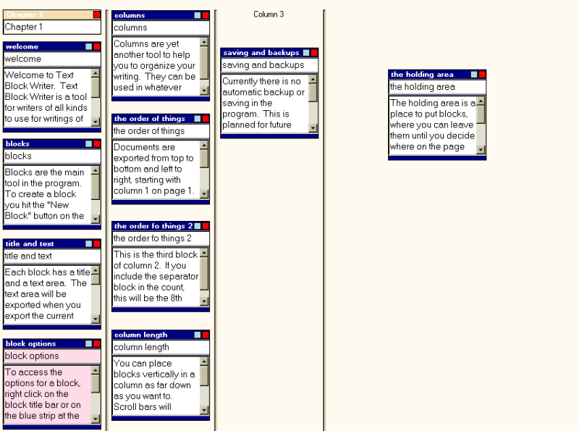
One of the things I really love about this program is that when those random ideas occur to me–you know the ones you don’t know how you’ll use but you totally have to write down? Well I just made a block, wrote it down, and chunked it in the holding area over there on the right until I knew how to use it. This sort of thing is handy for a single story or, as my CP was doing, to manage characters and notes for an entire series. And for those people who like to color code things, you can do that as well. I had different color blocks for different types of notes. And I could also change the color of the background of the block to indicate the status of the scene (white for outline status, yellow for draft, green for written). In any event, there is a lot of flexibility with this program, and I think you should check it out.
Moving on, here’s one of my very dear favorites for when I write romantic suspense (favorite because in RS, timeline specifics are very important for my story). Storybook is an open source software you can find at SourceForge. I’ve seen it through many many versions and each one improves things. One of the absolute coolest things about Storybook is that they have a wishlist forum where you can make suggestions or report bugs and if it’s feasible then Martin (the creator) or one of his programmer buddies will put it in a future version. I’ve had several of my suggestions incorporated over the last couple of years. How often is it that software developers actually LISTEN to the people who use their program? Seriously.
So okay, an overview. There is no way you can read this tiny print, so I encourage you to open the full image in a new tab if you’d like to see what I’m actually talking about. Or better yet, download it yourself. Done that? Okay, so this is your main page (I’ve opened the demo included with the download, as I don’t have a current project with me that I can use as an example). What you’re looking at is the chronological view. Those three columns you see are three different story strands–think of them as the plot threads you have to keep up with. See how they’re nice and color coded? They are also arranged from top to bottom in chronological order. For a book that has a very specific timeline where you absolutely need to know whether this thing happened on Monday, March 16, 2009 or on Wednesday, this is the program for you. To the right you can see a File Tree showing lists of Characters, Locations, Chapters, Strands, and Parts. Let’s look at some of these in detail.
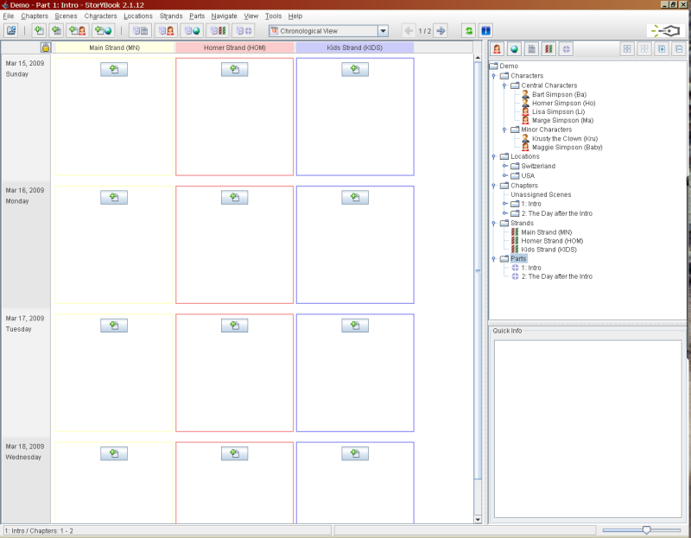
What you see below is the Character box for Bart Simpson. You’ve got your basic options for gender, major or minor character, name, birth and death days, occupation, and a choice to color code him. I find this handy when looking at who is in each scene. There are also tabs for description and general notes on the character. In either of these places you can put your more detailed character worksheets if you are inclined to do so.
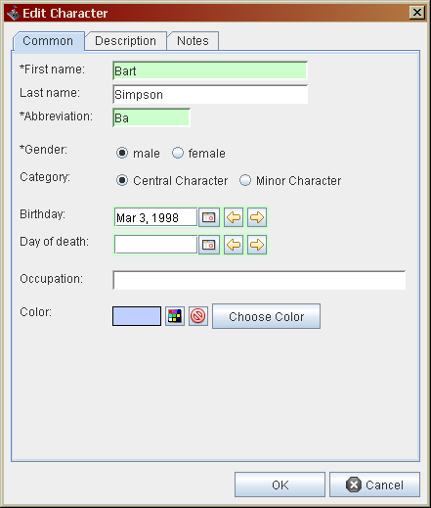
Next up you see the edit scene box. Notice how you can check off which strands this scene deals with? You also can specify chapter, the status (outline, first draft, done type thing), number the scene (and I think they now allow you to drag and drop to reorder scenes). The thing I ran into trouble with was the required date. Since this program DOES so heavily rely on chronology for much of its organization, you have to stick a date in there. Sure you can totally make them up (and I often did), but sometimes I just didn’t have a date. I didn’t know when stuff would happen. And until I made a date up, I couldn’t save the scene. Martin’s still working on a way around this, but apparently it’s really really complicated from a programming standpoint. In any event, this is AWESOME for keeping track of timelines if that’s very important to your plot.
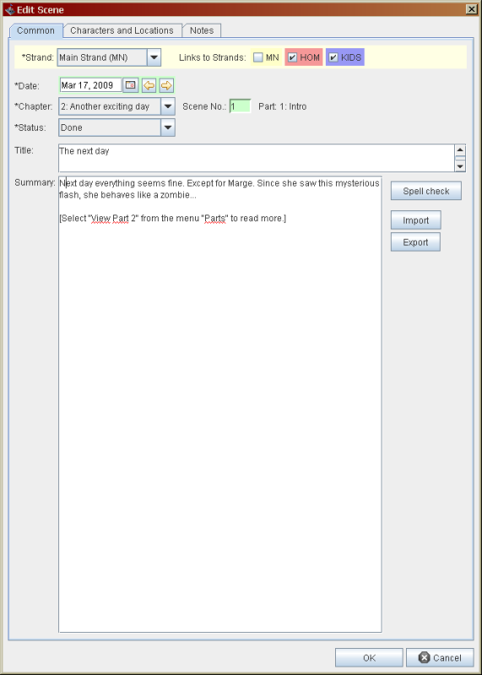
Below you see the Book View of your project. This is the one I use most often because it’s how I write. I go in chronological book order from scene one to scene two and so on. This view immediately told me what strand I was working on, who was in the scene, where it took place, when it took place, and gave me the summary of whatever I was supposed to be writing. I also seem to remember that there is a color coded frame system that indicates the status of the scene.
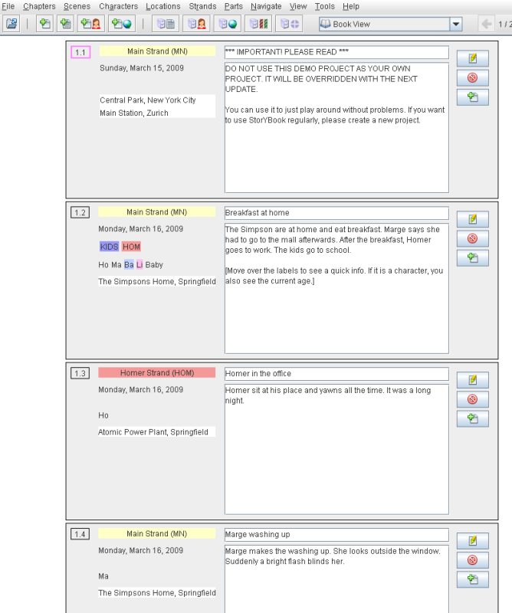
And finally, you have the charts. Blame it on my background as a scientist, but I love charts. In this case, you have the following options available, which is really fabulous for managing large casts, figuring out where people where at what point in the story, etc. I can see this being really useful to anyone writing mystery or another story where it was imperative to keep close tabs on who was where when. There are plenty of other features that I’m not highlighting now (because this is already running long), so I’ll just say that if you’re interested download it.
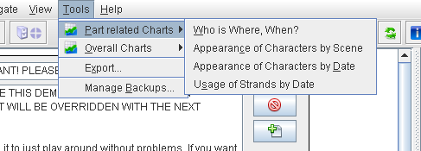
Now, the piece de resistance, I want to introduce you to my favorite of all the various programs I have tried. Hal Spacejock author Simon Haynes has created yWriter, currently in version 5. Like all the other programs I have mentioned here today, it is free, and it is awesome. I talked yesterday about the scene and sequel constructs by Swain? Yep, this program is designed with them in mind. This is another one of those you’ll need to open in another screen to see what you’re actually looking at. Below is the overview screen. This is what you see when you open a project. To the left I have all of my planned chapters listed (I happen to expect 28 chapters with 2 scenes each for this book, but you can absolutely add them one at a time as you go, if you prefer), with the total word count of each, plus the cumulative word count. In the box to the right, you see the listing of scenes in the selected chapter, which tells you the POV character, number of words in the scene, title of the scene, status of the scene, who is IN the scene, where it takes place… And at the bottom, that red, yellow, and green thing? Yeah, that’s the Goal, Conflict, Outcome. You will also see tabs for the Characters, Locations, Items (that pipe wrench that Professor Plum took into the library would be listed here), Scene Notes, Content, and Description. Some of these I find a bit redundant for my purposes, but that’s up to you.
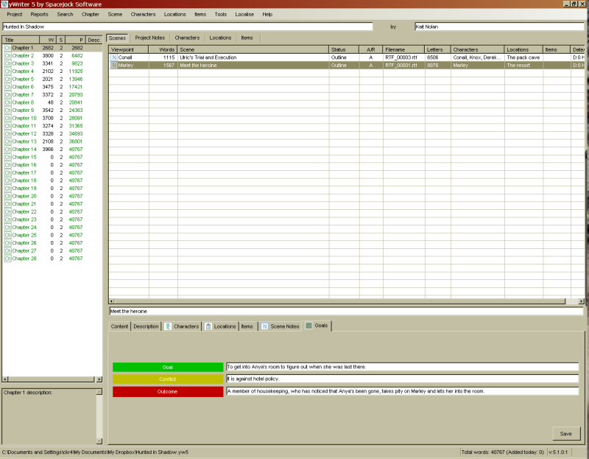
Now when you create a blank scene you get the following. You pick the chapter it’s in, name the scene, select whether it is an Action or Reaction scene (scene vs. sequel)–which gives you the Goal, Conflict, Outcome or Reaction, Dilemma, Decision at the bottom to fill out–, pick if it’s part of the main plot or the subplot, the POV of the scene, and if you’re really into it, you can pick exactly what day, hour, and minute the scene starts and how long it lasts. I don’t know what those rating things are about. I don’t use them. There are multiple other tabs–the same ones you’ll see on the main page. The Content tab is where you actually write the story if you are so inclined to use this as your main Word Processor. You can later export it into a Word file. This is what I choose to do (though I know full well I’ll end up doing a full read through of the final exported draft just to fix formatting crap).
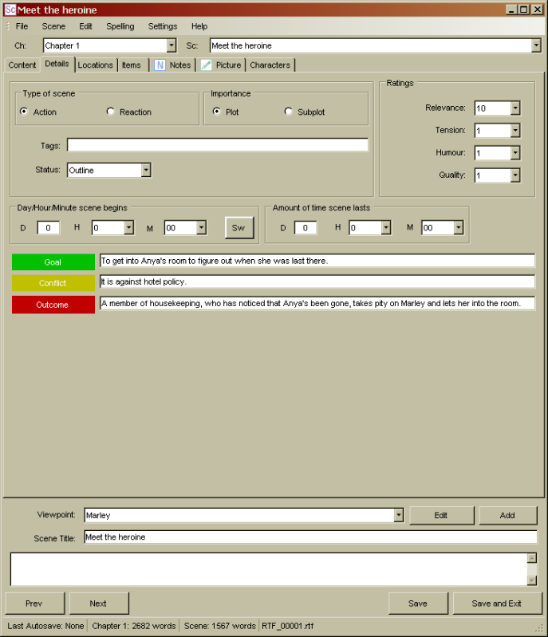
Now you see that tab for Notes? This is where I make use of my little scene worksheet. At the top I type up whatever I know about the scene. This was an early one, so I was very clear on exactly what happened when. Some scenes I have are not even total sentence summaries. You can make this as detailed or as vague as you want. Then at the bottom, I paste in my scene worksheet and fill it out.
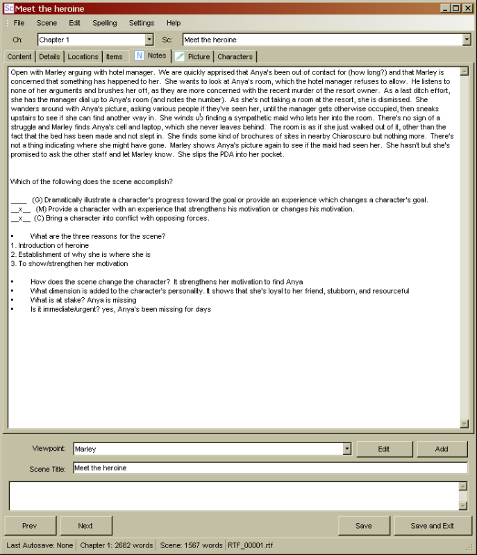
There are assorted reports you can print, summaries, full outlines of whatever notes you’ve made. Adding and removing scenes and chapters is only a few button clicks and with another click or two, it will renumber chapters for you. There are also drag and drop capabilities if you need to move a scene or a chapter. There are room for project notes as well, though I don’t really use those. Other features include a storyboard that will list scenes by character (as in showing all the scenes a character is in, in order), scene lists that will simply give you a full list of all planned scenes (also in order), and even a word usage tracker so you can see if you overdo it with some particular word in your manuscript or a Find Problem Words feature (either preset or user defined). And for the truly organized and disciplined, yWriter also allows you to set a work schedule that will give you a daily writing target (in number of words based on the date you say you want stuff done).
There are, of course, detailed pages for Character Sheets, Locations, Items, etc. Again, you can put as much or as little info in here as you like. I personally have pics of my hero, heroine, and villain in their profiles. There’s a Goals tab in there for each character as well, and that’s where I put my GMC info for each one. I think that’s one of the things I love most about this program is that there are plenty of essentially blank tabs that I can turn into whatever I personally need. So I have easy access to all my information with just a few clicks, in just one program.
That’s really the hallmark of something that WORKS. Something that can be used by lots of different people in different ways. So even if you’re a die hard pantser, I encourage you to take a look at some of these programs. Storybook might be a bit much for a true pantser, but both Text Block Writer, and yWriter can easily be adapted for use by pantsers. See if some of them work for you. Sometimes a bit of organization is all the muse needs to take off in a new direction.

From Pantser To Plotter: Why Plot?
by Kait Nolan
It’s been a big week here at Shadow and Fang. I think I’ve written my two longest blog posts to date. If you’ve stuck with me this far, congratulations. You clearly have stamina! So far I’ve talked about Why The Pantser Fears Plotting, My Problems With Pantsing, the Craft and Organizational methods I use in my own plotting, and now I want to try to tie things up.
In the name of presenting a balanced argument, I want to talk first about my problems with plotting. Yes, the plotting cheerleader DOES have problems with it. Who knew?
I suppose my biggest problem with plotting is that I can’t do just that. For my current project, which is the most plotting I have ever done to date, I spent three whole months plotting. I went from beginning to end (though some of the middle was a bit fuzzy). I was incredibly proud of myself, and I worked very very hard. I could see how the whole thing would work, how all the plot arcs connected, the reasons for almost every scene. And then I sat down to actually write it. And I froze. I could see it in my head, kind of like a movie playing in my brain, but I couldn’t find the words. In my determination to plot the whole damn thing out (which was largely to prove that I could), I didn’t write a bit of prose during those three months. So when I sat down to start writing the actual book, I’d lost my voice. I’m one of those people who must write every day, or at least not take more than a couple of days off, or I seem to forget what the heck I’m doing. Taking three months off was not smart on my part. It took me probably two months to FINALLY find my voice again such that my scenes didn’t sound stilted and stiff. You pantsers are probably saying “Yep, see, I know that would happen to me. That’s why I don’t plot.” Well there is a simple enough solution to that: Don’t stop writing while you’re plotting. In my case, that means plotting out the next thing while I am writing something else. So as I’m writing Hunted In Shadow (my current WIP), I am actually working on plotting out an entirely unrelated project. This also satisfies my tendencies to want to pursue Sexy Next Book. Once I’ve gotten my words for the day in, I’m free to plot on whatever I want. I figure I will fine tune the plot I’m working on as I’m doing revisions on this current project. I’ll keep you posted on how that goes for me.
So okay, other problems with plotting.
One misconception that I had was that plotting would make the writing boring because I already knew what happened. The thing is, an outline (in whatever guise you make it) is only a skeleton. I still definitely pants the details of each scene. That’s where my characters come to life, speak to me, and say “No! No! It happened like this!” This was something that Pot tried to tell me during my earlier attempts at plotting, and I was really resistant. It turned out that was mainly because my characters were motivationless brain dolls that I really just wanted to watch fall in love in my head and then take on a cruise on the S.S. Fluffyverse. But we won’t go there right now…
Another big problem with plotting is obviously that I just flat don’t know everything at once. And you know what? That’s totally okay. I absolutely have blocks where it’s really vague. For example, when I started with Hunted in Shadow back in November, all I knew was that there were 3 trials that the hero would have to pass in order to become Alpha. I didn’t have a clue what any of them were until…day before yesterday. And boy howdy did that change the direction of the 3rd Act! That’s what I’ve been working on all morning. Which brings me to what I believe is the number one myth about plotting:
If you plot you CAN and WILL change your outline/plot!
There is this absolute misconception among so many pantsers that plotting means that you must decide everything at once and that you’re not allowed to change it, as if it is set in stone or blood or you’d be breaking some unwritten rule. I hear so many of you (and I include myself as a former pantser) say that you deviate from your outline, often immediately, so what’s the point? Well, I’ll tell you.
When you get to those deviations, when new ideas occur to you that change things, the difference between the pantser and the plotter is that the plotter takes the time to figure out the repercussions of that change. What will that alteration change on down the plotline? This sort of analysis and thinking it through is what keeps those changes and alterations from being unnecessary tangents. You’ll know why you’re including every single scene, and you’re sure of what each one is supposed to be adding to the overall story and to the characterization of each character. And that saves you from having wasted three months writing in the wrong direction and another three months in revisions. That sort of follow through, of making the changes to your outline as new information occurs to you, will also enable you to figure out which ones are the crap scenes, the unnecessary scenes while you are still in outline form rather than after you’ve wasted time in writing them. I promise, it’s much less painful to axe them BEFORE they’re already written. One of the first things I did once I finally got into the writing of HiS was to axe or combine scenes because they weren’t enough on their own. And while I’m on the subject, it is so much easier to rearrange things in an outline than it is in a big, long, unwieldy manuscript. In yWriter I can simply drag a scene into whatever chapter I want. It takes 2 seconds. If I was working in a full pantsed manuscript, I’d have to scroll to find the section, select it, cut it, scroll to find where I wanted to stick it. It’s time consuming and clunky.
And this brings me to what is probably my number 1 reason for wanting to plot: Time Management.
Here’s the deal. I am a very busy woman. I work a full time research position with a major state university. I also have a full time teaching load as an online college instructor, and from time to time, I do freelance copy editing work. Add to that the usual responsibilities of keeping house, husband, and pets (God help me when I have kids), and it really doesn’t leave much time for writing. The thing is, I want to write for a living. I don’t want to keep having to do all this other stuff. Since that writing time is very limited, I want to make the best use of it. Pantsing things and going off on tangents wastes a LOT of time. And while I have absolutely gotten over my attachment and resistance to killing my darlings (my CP will tell you that I will fairly readily chunk tens of thousands of words if they aren’t what I need), I hate that I’ve wasted that time when some planning could have had me being more productive. It feels like a big setback in the Grand Plan For Kait. I’m not okay with that.
So I look to writing with the same kind ruthless of organization I use to manage all those other responsibilities. It takes me a good year to write a book. That’s just a fact. I can only turn out between 500-1,000 words a day most days. That means it takes me a good 3-6 months to get through a draft, assuming I’m consistently moving forward. Sometimes longer if I get stuck or life interferes (as it often does). When I have a plot, I have that roadmap to where I’m going. I don’t have to waste time pondering “I wonder what happens next?” or bugging my CP for that answer simply because I haven’t thought it through. If I pants, it takes me just as long or longer to go through revisions and try to fix the problems with the tangents and the wrong turns because I’m just as prone to making more of them. But if I plot, then when I finish that first draft, I have something solid to work with. It may need fleshing out or cleaning up, but generally, I’m going to have a FINISHED draft faster–not to mention that the draft will be more liable to stand on its own because I planned out the foundation rather than lucked into something that worked. And since I’m unpublished and untried in the great wide publishing world, it behooves me to do whatever I can to make sure that the things I’m putting out the door looking for representation are the best that I can make them.
Plotting gives me the confidence that they are.
Thanks for joining me as I’ve taken this journey through my conversion from pantser to plotter! I hope you’ve found some of this helpful. If you have any thoughts, questions, or requests for future posts on this subject, toss them in comments! And because I am out of books to give away, today’s prize will be a chance to be featured as a character in my current (or possibly next) paranormal romance project.

