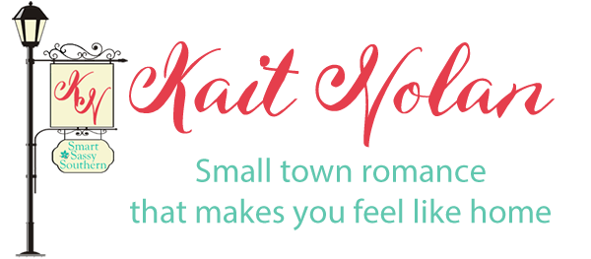
Title | Couple | Publication date | Formats available | Read | Reviewed
Wishful Romance
To Get Me To You | Norah and Cam | November 27, 2014 | Ebook/print/audio
Know Me Well | Riley and Liam | August 14, 2015 | Ebook/print/audio
Be Careful, It's My Heart | Tyler and Brody | November 9, 2013 | Ebook/print/audio
The Matchmaker Maneuver (Formerly Once Upon A Setup) | Piper and Myles | November 22, 2015 | Ebook
Just For This Moment | Piper and Myles | March 31, 2016 | Ebook/print/audio
Wish I Might | Cecily and Reed | November 3, 2016 | Ebook/print/audio
Turn My World Around | Corinne and Tucker | September 1, 2016 | Ebook/print/audio
Dance Me A Dream | Tara and Jace | November 25, 2016 | Ebook/print/audio
See You Again | Sandy and Trey | June 30, 2017 | Ebook/print
The Christmas Fountain | Mary Alice and Chad | November 22, 2017 | Ebook/print
You Were Meant For Me | Tess and Mitch | October 2, 2018 | Ebook/print
A Lot Like Christmas | Hannah and Ryan | December 1, 2018 | Ebook
Dancing Away With My Heart | Lexi and Zach | May 24, 2019 | Ebook
Wishful Romance Volume 1 |  | December 1, 2017 | Ebook/audio
Wishful Romance Volume 2 |  | March 22, 2018 | Ebook/audio
Wishful Romance Volume 3 |  | August 16, 2019 | Ebook

Meet Cute Romance
Once Upon A Snow Day | Isabelle and Brandon | December 19, 2013 | Ebook/print
Once Upon A New Year’s Eve | Gemma and Aaron | January 23, 2014 | Ebook/print
Once Upon An Heirloom | Sylvie and Everett | February 10, 2014 | Ebook/print
Once Upon A Coffee | Avery and Dillon | July 17, 2014 | Ebook/print/audio
Once Upon A Campfire | Sarah and Beckett | June 26, 2017 | Ebook/print
Once Upon A Wedding | Misty and Denver | August 25, 2017 | Ebook
Once Upon A Rescue | Brooke and Hayden | November 9, 2018 | Ebook
Misfit Inn
When You Got A Good Thing | Kennedy and Xander | March 30, 2017 | Ebook/print/audio
Those Sweet Words | Pru and Flynn | October 20, 2017 | Ebook/print/audio
Stay A Little Longer | Athena and Logan | January 18, 2019 | Ebook/print/audio
Bring It On Home | Maggie and Porter | November 22, 2019 | Ebook
Wishing For a Hero
If I Didn't Care | Autumn and Judd | October 27, 2016 | Ebook/Print
Watch Over Me | Rowan and Nash | May 8, 2018 | Ebook/Print
Can’t Take My Eyes Off You | Miranda and Ethan | June 1, 2018 | Ebook/Print
Can’t Stand The Rain | Delaney and Sean | July 13, 2018 | Ebook/Print

Rescue My Heart
Baby It's Cold Outside | Ivy and Harrison | January 25, 2018 | Ebook
What I Like About You | Laurel and Sebastian | July 19, 2019 | Ebook
Standalones
Second Chance Summer (RITA® Award Winner) | Audrey and Hudson | May 26, 2017 | Ebook/print
Red | Elodie and Sawyer | August 14, 2011 | Ebook/print

https://kaitnolan.com

